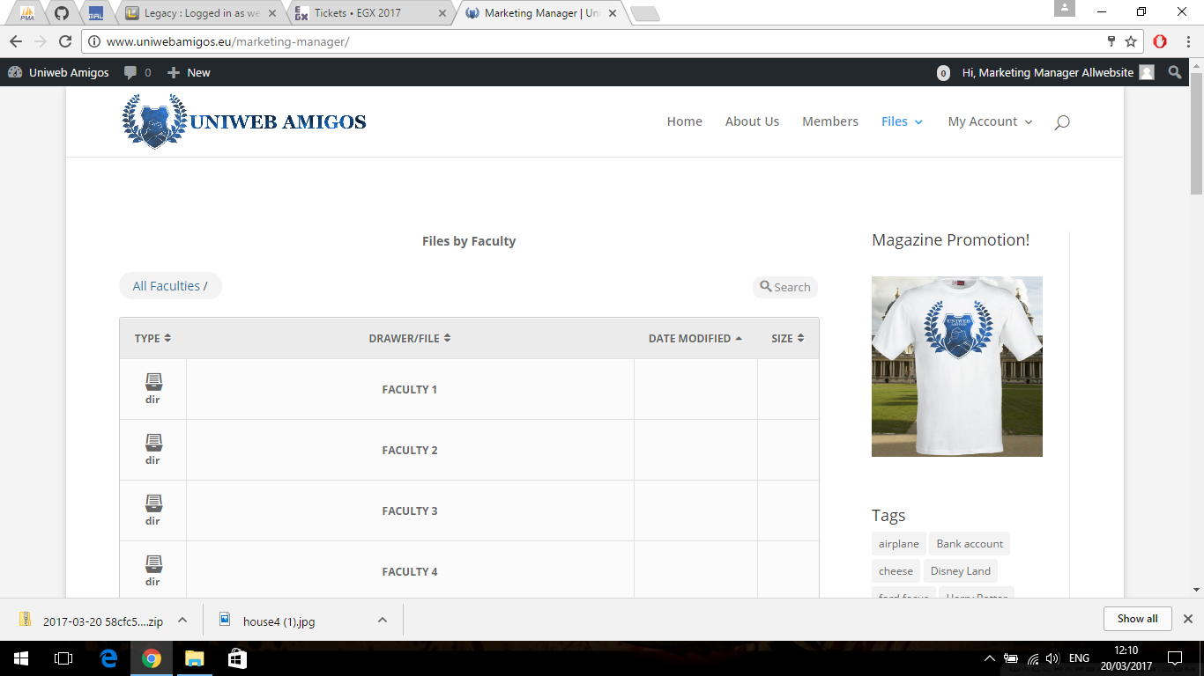

First we have the marketing manager home dashboard which has:

* Access to all the four faculty’s upload files
* Then below it has a showing of all the files that have been latest uploaded or modified
* Then there is also the magazine shirt promotion to for our users to look at
* There are also a few features here that allow you to select all the files and Download them into a zip folder from the recent uploaded and modified and from all of the faculties

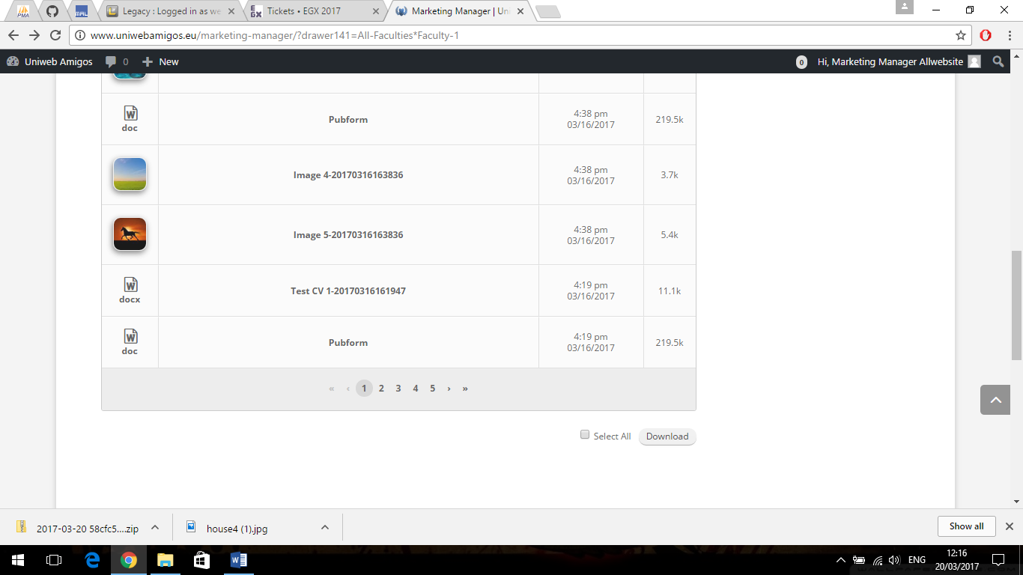

* Then within each of the faculties the manager can see all of files that have been uploaded in two directories and allowing the manger to download these file into a zip file by either clicking the one they want or select all and downloading them into a zip folder.

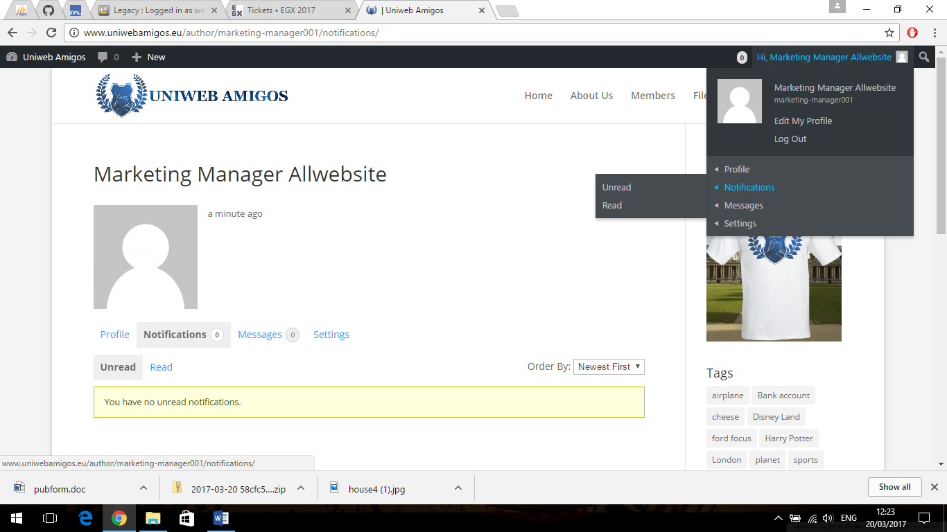

Then within the marketing manager there is the top of the dashboard that allows you to edit the profile and also to view any nonfictions or messages that they may receive.